Daily Report
Date : 06.02.26
Today Working: Today I have worked on Implemented and completed the authentication module with password and OTP-based login functionality. Developed multi-step OTP verification for signup with validation, OTP resend timer, and API integration.
Login Page Development
- Implemented dual login methods:
  - Email & Password authentication
  - Phone number OTP authentication
- Integrated API services
- Added success/error handling and loading states.
- Stored JWT token and user data
- Implemented navigation after successful authentication
Signup Page Development
- Built multi-step signup process:
  - User details form validation
  - OTP verification
- Integrated API services
- Implemented client-side validations:
- Implemented OTP resend with countdown timer.
- Stored authentication token upon successful registration.
.

Screenshots :

Login Page:
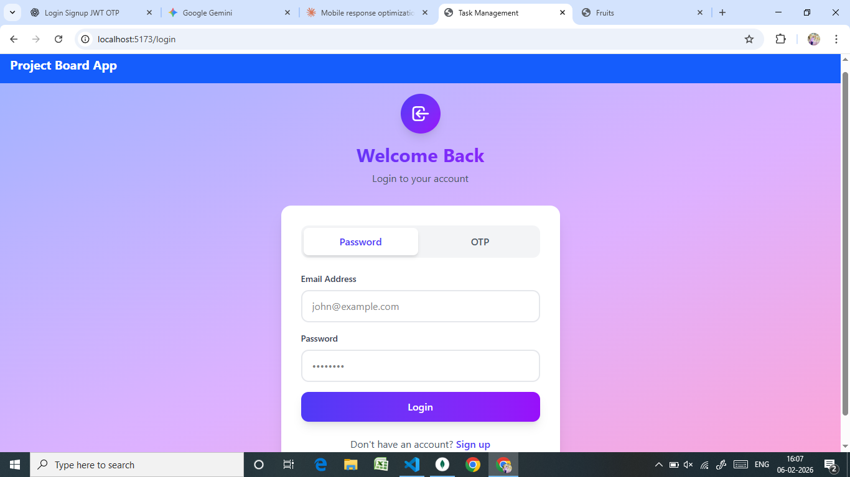

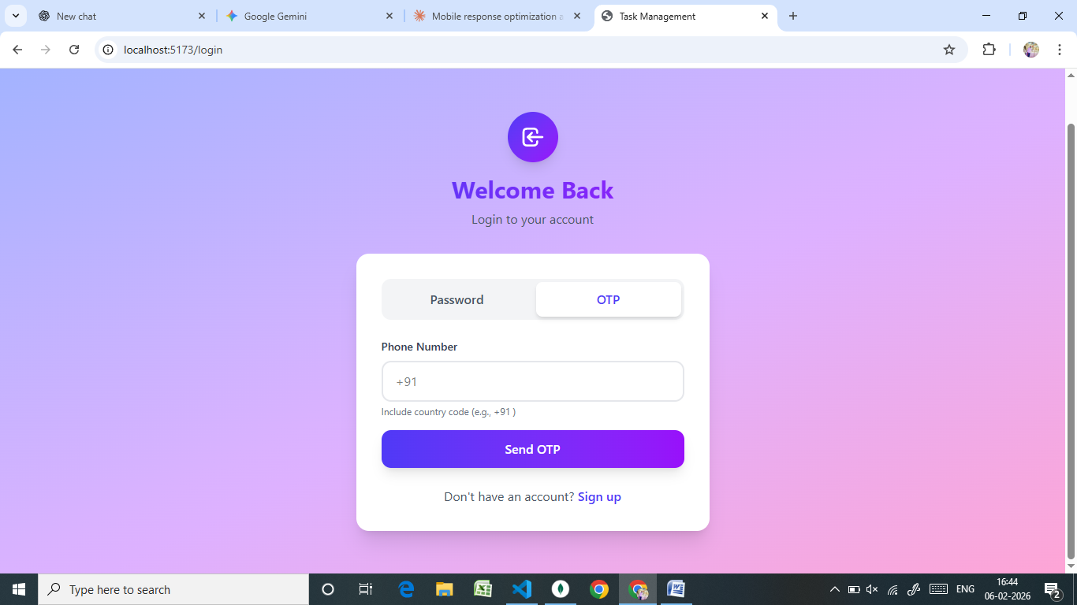
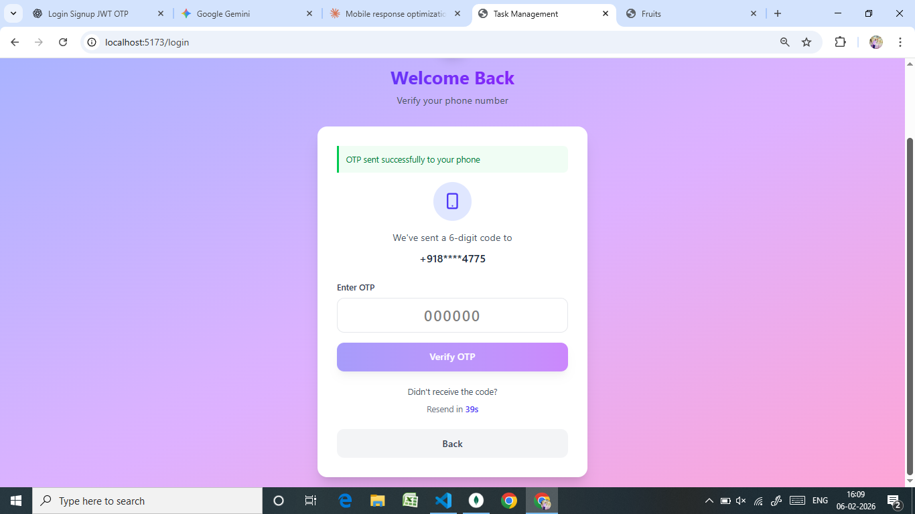

Signup Page:
